**TUTORIAL CHAPTER 6 AND 7**

1. At least how many replicates *r* are needed in order to be able to show interaction?
2. How are the following test results to be interpreted (*i.e.*, which model corresponds to the two (factorial design with fixed effects))?

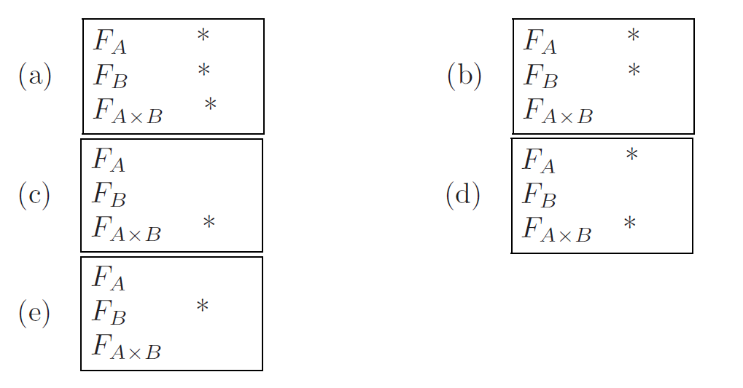

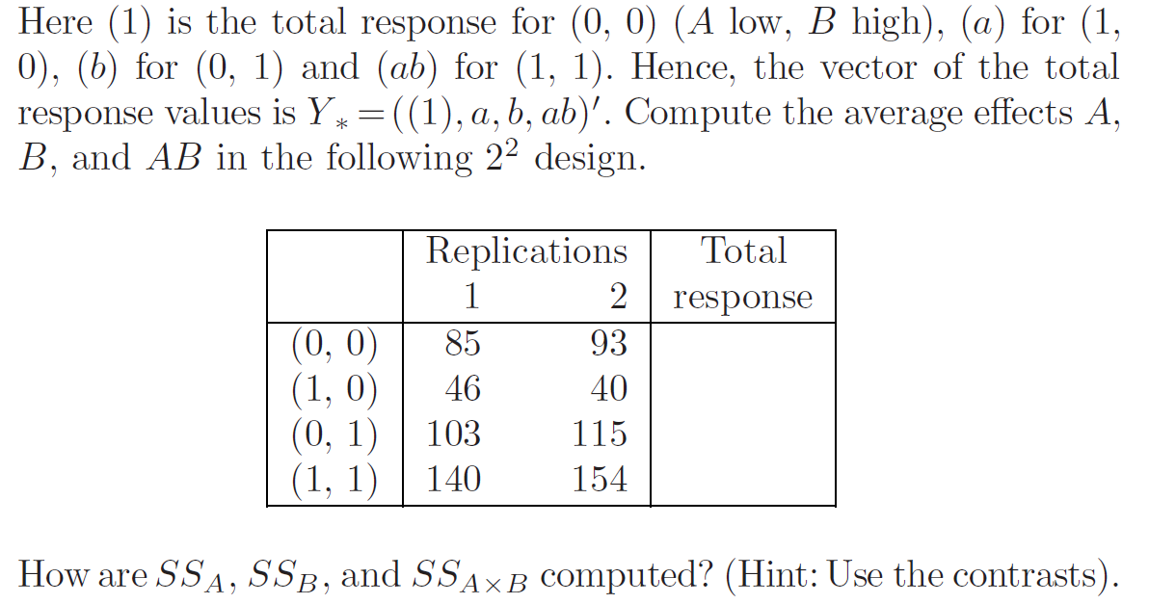

3. Construct an ANOVA table and draw conclusions.

4. find the means of treatment combinations and the factors (i.e. main and interactions).

1. An experiment was conducted on the shear strength of spot welds for three types of steel alloy. Six welds were made on each of the alloys and the force required to shear the weld was measured. The diameter of the weld was measured because it was believed that the strength of the weld was affected by its diameter. The data are shown in the table where weld strength and weld diameter.

|  |  |  |  |  |  |  |  |  |
| --- | --- | --- | --- | --- | --- | --- | --- | --- |
| **Alloy** |  |  | **Alloy** |  |  | **Alloy** |  |  |
| **1** | 37.5 | 12.5 | **2** | 57.5 | 16.5 | **3** | 38.0 | 15.5 |
| **1** | 40.5 | 14.0 | **2** | 69.5 | 17.5 | **3** | 44.5 | 16.0 |
| **1** | 49.0 | 16.0 | **2** | 87.0 | 19.0 | **3** | 53.0 | 19.0 |
| **1** | 51.0 | 15.0 | **2** | 92.0 | 19.5 | **3** | 55.0 | 18.0 |
| **1** | 61.5 | 18.0 | **2** | 107.0 | 24.0 | **3** | 58.5 | 19.0 |
| **1** | 63.0 | 19.5 | **2** | 119.5 | 22.5 | **3** | 60.0 | 20.5 |

1. Use weld diameter as a covariate for weld strength, and write a linear model for the experiment, identify each of the terms in the model, and state the assumptions for the model.
2. Ignore the covariate analyse the data and draw conclusion.
3. Conduct the analysis of covariance, and test the significance of the covariate and adjusted treatment means.
4. Suppose that in a complete factorial experiment three binary factors *A*, *B*, *C* are to be studied. The number of combinations is eight and with *r* replicates we have *N* = 8*r* observations that are to be analyzed for their influence on a response.

|  |  |  |  |  |
| --- | --- | --- | --- | --- |
| **Factor B** | | | | |
|  | **0** | | **1** | |
|  | **FACTOR C** | | **FACTOR C** | |
| **FACTOR A** | **0** | **1** | **0** | **1** |
| **1** | 4 | 2 | 4 | 14 |
|  | 11 | 7 | 6 | 16 |
| **0** | 4 | 7 | 20 | 10 |
|  | 5 | 9 | 14 | 6 |

1. Find the means of each treatment combinations.
2. Find the means of the main and interaction factors.
3. Using the means from 1 apply Yates algorithm to draw conclusions about the given problem.
4. Using the means from no.2 apply the contrast method.
5. Suppose the manager of a gym has three proposed exercise programmes, P, Q and R, to evaluate. Twenty-four people, 12 females and 12 males, volunteer to test the programmes. Four females and four males are assigned randomly to each programme, and at the end of 6 weeks the response variable is a measure of improvement in cardiovascular fitness. A table of (fictitious) data and means follows:

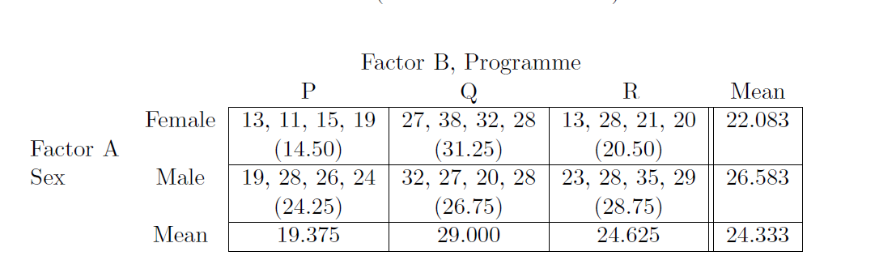

1. Write a statistical model.
2. Analyse the data and draw conclusion. Perform pairwise comparison for the main effects in necessary using SNK method.
3. In a large factory, with many Operators, Parts, and Devices, an experiment is conducted to measure the variation in measured strengths of parts. Samples of 5 Operators, 10 Parts, and 3 Devices were obtained; with each combination of Operators, Parts, and Instruments being replicated 2 times. The following model is fit (with all random effects independent).
4. Write out the appropriate statistical model, stating all elements (parameters and random variables) and ranges of subscripts.
5. Complete the following ANOVA Table and test first and order interaction at 5% level.

|  |  |  |  |  |
| --- | --- | --- | --- | --- |
| Source | df | SS | MS | F |
| O |  | 800 |  |  |
| P |  | 450 |  |  |
| D |  | 400 |  |  |
| OP |  | 720 |  |  |
| OD |  | 240 |  |  |
| PD |  | 90 |  |  |
| OPD |  | 144 |  |  |
| Error |  |  |  |  |
| Total |  | 3144 |  |  |

1. In addition: SOLVE PROBLEMS FROM THE GUIDE RELATED CHAPTER 6 AND 7 (QUESTIONS ARE IN CHAPTER 8).